Firearm Technology and Specialist Training
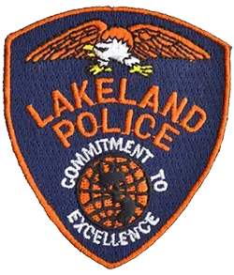
This training seminar is being hosted by the Lakeland, Florida Police Department.

Training Goals: This is an intense course designed to teach anyone from novice to the highly-experienced, the complete picture of the firearm field, make you a competent Specialist, and put you on the pathway to becoming one of the most firearm-knowledgeable people in the country. Post-seminar online testing is included, which certifies the attendee as a Firearm Specialist upon successful completion.
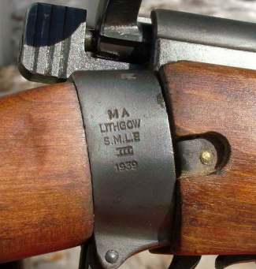
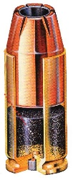
Attendees are taught 14 aspects of the field of firearms/ammunition at a crawl-walk-run pace. Most reach the ability to pass the online quizzes shortly after the seminar but have up to 6 months to do so at their leisure, if further study is needed, using our included online videos.
Attendees will be able to encounter a wide variety of firearms and ammunition, and be able to safely clear, accurately identify, to classify, and to competently categorize any firearm or ammunition, even the oldest obscure foreign military examples, all within ATF and State guidelines. They will be confident in making determinations as to Gun Control Act and National Firearms Act status and avoid overlooking violations and items which are illegal contraband. The issues of mis-ID, unfamiliarity with obscure facets of the firearm field, and unsafe practices will be solved, avoiding the misinformation and lack of information which plagues law enforcement and the firearm industry.
The course is designed to enable one to immediately interpret what he/she sees, and to apply their knowledge in making an accurate determination as to an item’s origin, it’s status under the law, and its method of mechanical operation. All areas of the field of firearms and ammunition will be examined and discussed thoroughly, and Federal law and ATF rulings will be cited to prove all points taught.

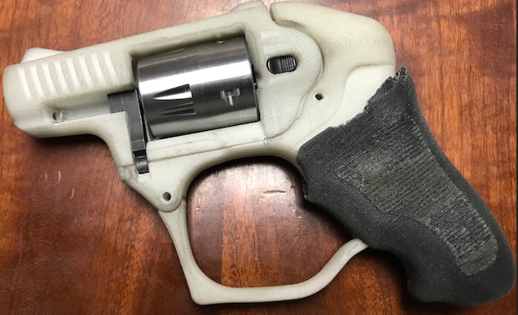
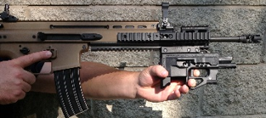
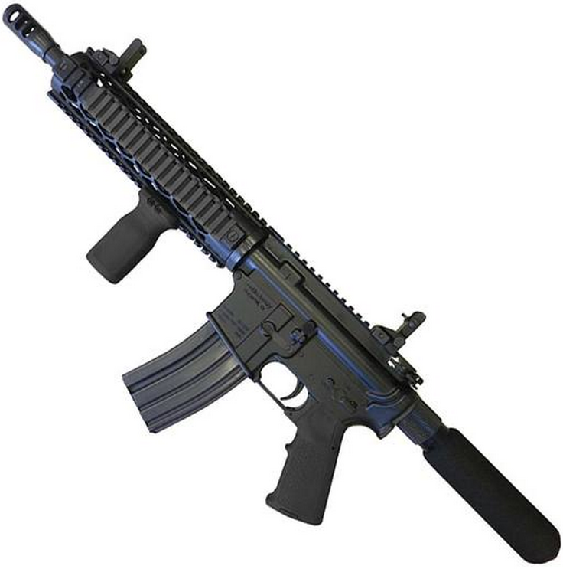
The latest firearm technology trends in the industry, as well as criminal-trends will be explained. These will help the professional become acquainted with technical concepts not familiar to the beginner, and which will acquaint the firearm professional with clandestine silencers and full-auto conversions, Curios and Relics, home-built firearms, ATF Tracing, etc... There is an emphasis on understanding ammunition, the accurate identification of guns and ammunition.
Audience: This training is open to members of law enforcement, and to other government agencies, military, security, firearm industry, Attorneys, Crime Scene Technicians, Property and Evidence Technicians, etc.
Methods: The course is a 3-day session. The course-author is a former ATF National Academy firearm-staff member. Attendees will perform hands-on examinations of real firearms. Numerous handouts are also provided as instructional aids, and attendees will receive a certificate of attendance. This training is also recognized by the IAI, ABMDI, NSSF, Sonoran Desert Institute, CSI Academy of Florida, Brighton College and numerous federal and large state and local law enforcement agencies, and we are a Technical Advisor to AFTE.
Day One:
- Firearm Safety and Clearing (rules of safe handling, clearing procedures, safety precautions, active and passive safety devices, test-firing cautions, jammed firearms)
- Firearm Classification (5 categories of Gun Control Act firearms, definitions of “firearm” and “antique” [non-gun], forearm-braces, vertical fore-grips, 80% receiver blanks, dummy guns, home-made guns)
- Markings (manufacturer, importer, proof, obliterated serials, double serials, double importers, trademarks, ATF variances, hidden serials, Nazi codes, catalog guns, foreign military gun-ID, ATF Tracing)
- Nomenclature (ID of parts necessary for safety and/or location of markings)
Day Two:
- Ammunition (components, ID, technology, interstate nexus, chamber pressure, headspace, SAAMI)
- Cycle of Operation (the function of each step of mechanical operation)
- Mechanical Types of Operation (breech and muzzle-loaders, self and manually-loaded firearms, action types, open and closed-bolt, semi and full-auto)
- Curios and Relics (collector status granted by ATF, C&Rs vs. antiques)
- NFA Rifles/Shotguns (short-barreled rifle/shotguns, weapons made from rifle/shotgun, shoulder-stocked handguns, sub-caliber inserts)
Day Three:
- Machineguns (Ten most common clandestine conversions, field testing, bump-firing, Gatling guns, deactivated war trophies, re-welds, fire-on-release, methods of destruction)
- Silencers (recognition, soda-bottle and oil-filter adapters, solvent traps, fakes)
- Any Other Weapon [AOW] (disguised firearms, smooth-bore handguns, handguns w/vertical fore-grip,
Marble Game-getters)
- Destructive Devices (bombs, mines, grenades, bores over .50 caliber, Street-sweeper, USAS-12, Molotov cocktails, IEDs, exceptions)
- Court Testimony (15 points on preparation, writing a Curriculum Vitae, and the pitfalls of testimony)

Seminar location:
Lakeland Police Department Firearm Range
3131 Centurion Dr.
Lakeland, FL 33805

Date: April 23-25, 2024
Time: 8:00-4:30pm

Cost of the 3-day course is $575/person, which includes post-seminar online review videos and quizzes for certification.

To register, contact IFSA at (813) 422-4674 or email: Info@GunLearn.com. The registration form is here at https://www.gunlearn.com/wp-content/uploads/2018/04/IFSA-registration-form-3.28.18.pdf To learn more about IFSA/GunLearn, go to www.GunLearn.com .

Attendees are cautioned that the course includes the handling of firearms, and as a result, no live ammunition is allowed in the classroom. Prior arrangements should be made for safe storage of duty weapons and ammunition. Due to the inherent handling of firearms in the class, attendance is restricted to those who are not prohibited from possession of a firearm or ammunition under Title 18 U.S. Code 922 (g).

